INDIVIDUAL ASSIGNMENT
PROBLEM SOLVING & DATA ORGANIZATION
JavaScript Implementation

Field | Information
Full name | Lam Ngoc Kien
Student ID | 134010126001
Class | K26ISTG01
Language | JavaScript (Node.js)
Submission date | 03/10/2026

Project scope: 5 basic algorithms + 3 data organization problems + BFS/A* maze optimization

1. Objectives and Scope
The goal of this individual assignment is to demonstrate practical problem solving, appropriate data organization, complexity analysis, testing, and performance comparison. The project is implemented in JavaScript and runs with Node.js in the console.

Objectives
- Implement the five required basic algorithm problems with clear input validation and edge-case handling.
- Select and implement three data organization problems with data structures chosen for their operational requirements.
- Implement two shortest-path algorithms for a 2D maze and compare their runtime and search behavior.
- Create repeatable unit tests and a benchmark that can be executed from the command line.
- Keep the repository simple and dependency-free by using the Node.js standard library.

Project Structure
The implementation is intentionally separated into small modules so each problem can be studied and tested independently.
Folder/File | Purpose
src/basicAlgorithms.js | Five required algorithmic problems.
src/contactManager.js | Contact Manager using Map.
src/gameRanking.js | Top 10 ranking using a min-heap.
src/lruCache.js | LRU cache using Map ordering.
src/maze.js | BFS, A*, and benchmark-maze generation.
src/main.js | Interactive console demo with Choose menu.
tests/*.test.js | Unit tests using Node built-in test runner.
benchmark.js | Performance benchmark for BFS vs A*.
docs/ | Complexity notes, demo guide, report, and diagrams.

2. Part 1 - Basic Algorithms

2.1 N-th Prime Number
Approach: generate integer candidates from 2 upward and test primality by checking divisors only up to the square root. The function validates that N is a positive integer.
Complexity: for the N-th prime p, the implementation performs repeated trial-division checks. A practical upper description is O(n sqrt(p)) time with small auxiliary space.

2.2 Reverse a String Without reverse()
Approach: traverse the string from its last character to its first character and append each character to a result string. No Array.prototype.reverse() or equivalent built-in reverse operation is used.
Complexity: O(n) time and O(n) space for the returned string.

2.3 Palindrome Check
Approach: use two pointers, one at the beginning and one at the end. Non-alphanumeric characters are skipped, and comparisons are performed case-insensitively.
Example: "A man, a plan, a canal: Panama" is treated as a palindrome after spaces and punctuation are ignored.
Complexity: O(n) time. The algorithm itself uses O(1) pointer state, while the JavaScript string representation remains proportional to input size.

2.4 K-th Largest Integer
Approach: copy the array, remove duplicate values, sort in descending order, and select index k - 1. Input validation handles invalid k and non-integer elements.
Complexity: O(n log n) time and O(n) auxiliary space.

2.5 Character Frequency
Approach: use a Map from character to count. Each character updates one Map entry, so the algorithm performs one linear pass over the input.
Complexity: O(n) time and O(u) space, where u is the number of distinct characters.

3. Part 2 - Data Organization

3.1 Contact Manager - Map
The contact manager normalizes a contact name and stores the contact as a value in a Map. The normalized name becomes the key. This directly matches the requirement for fast searching by name.
- Average add/find/delete: O(1).
- Update: O(1) average when the key already exists.
- Space: O(n).
- Edge cases tested: duplicate names, invalid email, missing contact, and case-insensitive search.

3.2 Game Ranking - Min-Heap
The ranking problem needs fast Top 10 retrieval. A min-heap with capacity 10 keeps only the best ten scores. The smallest score among the current Top 10 stays at the root, so a new score replaces it only when the new score is better.
- Space: O(10), effectively constant for a fixed Top 10 requirement.
- Each heap insertion is O(log 10), effectively constant.
- Scanning m players costs O(m log 10).
- Final Top 10 output is sorted descending for display.

3.3 LRU Cache - Map
The LRU cache uses Map insertion order. A cache hit deletes the existing key and re-inserts it, making it the most recently used. When capacity is exceeded, the first key in Map order is removed.
- Average get/put: O(1).
- Space: O(capacity).
- Edge cases tested: eviction, repeated update of an existing key, and cache size limit.

Why These Structures?
The data structure is chosen from the main operation: Map for direct key lookup, a min-heap for maintaining a small Top N set, and Map ordering for an efficient LRU policy. This avoids treating every problem as a generic array problem.

4. Part 3 - Maze Optimization

4.1 Problem Definition
Given a 2D grid, 0 represents an open cell and 1 represents a wall. The program must find a shortest path from a start cell to a goal cell using four-directional movement.

4.2 BFS
Breadth-First Search explores cells level by level. In an unweighted grid, the first time the goal is reached, the path is shortest. A queue stores the frontier and a visited set prevents repeated exploration.
Complexity: O(V + E), which is O(V) for a grid with a constant number of neighbors per cell. Space: O(V).

4.3 A*
A* uses a priority queue and evaluates f(n) = g(n) + h(n), where g(n) is the path cost from the start and h(n) is the Manhattan-distance heuristic to the goal. The heuristic is appropriate for four-directional movement without diagonal steps.
Complexity: worst-case O(V log V) in this implementation because of heap operations, with O(V) space. In suitable mazes, the heuristic can reduce the number of cells explored.

4.4 Correctness Check
For each benchmark maze, BFS and A* are run on exactly the same grid, start point, and goal. The recorded path distances match, which confirms that both implementations return the same shortest-path length for the benchmark inputs.
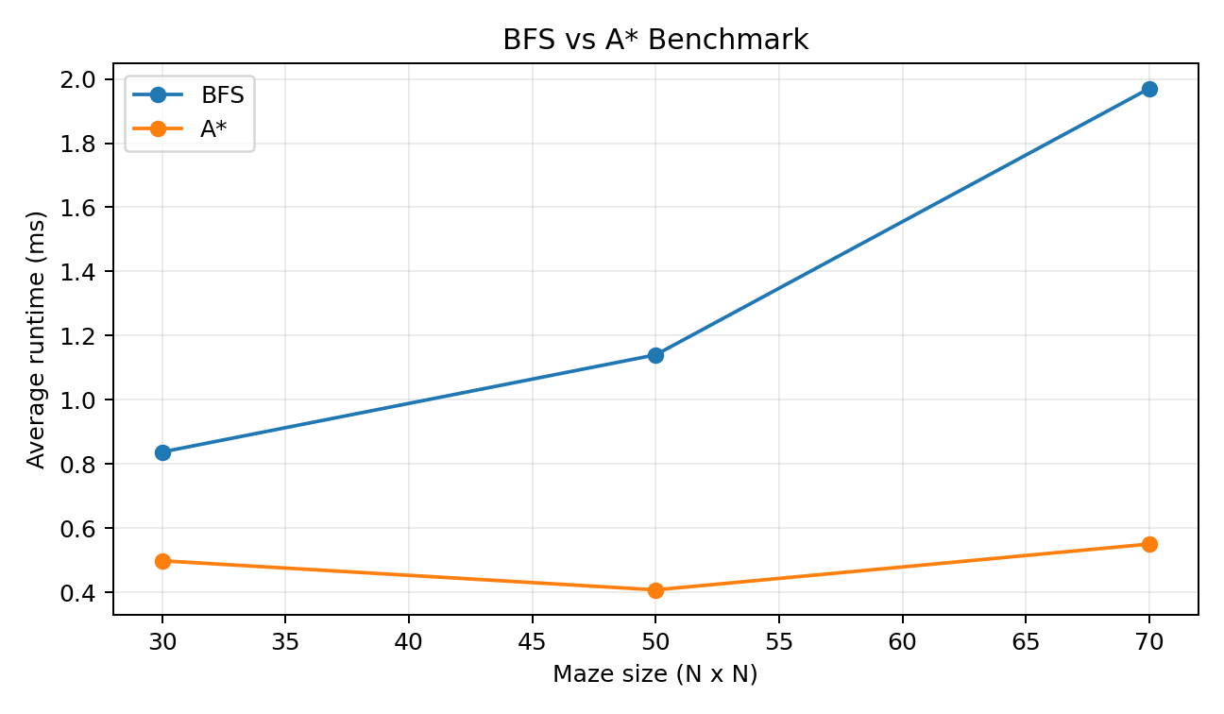
Figure 1. Average BFS and A* runtime from the executed benchmark.

5. Benchmark Results and Interpretation
The benchmark uses Node.js performance.now(). Each maze size is solved 30 times per algorithm, using the same maze instance for the comparison.
Maze | Repeats | BFS ms | BFS dist. | BFS visited | A* ms | A* dist. | A* visited
30 x 30 | 30 | 0.8374 | 58 | 738 | 0.4982 | 58 | 312
50 x 50 | 30 | 1.1402 | 98 | 1983 | 0.4076 | 98 | 683
70 x 70 | 30 | 1.9702 | 138 | 3828 | 0.5504 | 138 | 850

Interpretation
The benchmark shows that A* visited substantially fewer cells than BFS on the generated mazes, while also having lower measured average time for these inputs. This is consistent with the role of the heuristic: the search is directed toward the goal instead of expanding uniformly in all directions.
The result should not be generalized to every maze. A* has priority-queue overhead, and its advantage depends on the quality of the heuristic and the geometry of the maze. BFS remains a strong baseline because it is simple and guarantees a shortest path in an unweighted grid.

Reproducibility
Run `npm run benchmark` to regenerate data/benchmark_results.csv. The benchmark is deterministic with respect to maze construction, while the measured runtime can vary slightly by machine and current system load.

Sample Output File
The CSV file included in the submission stores the exact benchmark values produced during project preparation. It can be opened directly in a spreadsheet application.

6. Unit Testing and Edge Cases
The project uses Node.js built-in test runner via `node --test`. This keeps the project lightweight and removes the need for an external test framework when the assignment only requires unit testing.
Test area | Examples covered
Prime | 2 is prime, 1 is not prime, invalid N.
Reverse string | normal string, empty string, longer string.
Palindrome | punctuation/spaces, mixed case, empty string.
K-th largest | duplicates, first/third rank, invalid k, empty array.
Character frequency | repeated characters, empty input.
Contact Manager | CRUD, duplicate name, invalid email, case-insensitive search.
Game Ranking | 20 players, exactly Top 10, score update.
LRU | eviction, repeated key update, capacity limit.
Maze | shortest path, A* distance equality, unreachable goal, invalid maze.

Test Execution
During preparation, the test suite completed with 18 passing tests and 0 failing tests.

Continuous Integration
A GitHub Actions workflow is included under `.github/workflows/ci.yml`. It installs the repository and executes `npm test` on pushes and pull requests.

Repository Practice
The README recommends small daily commits with clear messages such as `feat: solve five basic algorithms`, `test: add edge cases`, and `perf: benchmark BFS and A*`. This makes the problem-solving process visible in Git history.

7. Difficulties, Lessons Learned, and Future Work

Difficulties Encountered
- Choosing the data structure based on the dominant operation rather than personal preference.
- Handling duplicates and invalid k values in the K-th largest problem.
- Keeping BFS and A* comparable by using the exact same maze inputs and start/goal positions.
- Implementing a priority queue for A* without adding a third-party library.

Lessons Learned
- Map is a practical choice when the application repeatedly searches by a stable key.
- A small fixed-size heap can maintain Top N without sorting every score after every insertion.
- An LRU cache can be built with the insertion-order behavior of Map.
- Benchmarking should measure both runtime and algorithm behavior such as visited cells.
- Good edge-case tests often reveal more than a large number of ordinary test cases.

Future Work
- Add Quickselect for an average O(n) K-th largest solution and compare it with sorting.
- Add a larger randomized maze benchmark and report median as well as average runtime.
- Add more data-structure alternatives such as a balanced search tree or explicit doubly linked list LRU.
- Add input-file support and larger benchmark datasets.

Submission Checklist
- Replace student information placeholders.
- Create a public GitHub repository and push the full project.
- Run `npm test` before submission.
- Run `npm run benchmark` and keep the generated CSV.
- Add GitHub and demo-video links to the final report.

References
The implementation is based on standard algorithm and data-structure concepts covered by the assignment brief. Suggested learning references include Cracking the Coding Interview, Introduction to Algorithms (CLRS), LeetCode, HackerRank, GeeksforGeeks, and Abdul Bari / freeCodeCamp educational materials.

